Resources for Remote Delivery/Online Teaching on the fly
Compiled by
Reut Livne-Taradach
Assistant Professor of Management,
Management and Marketing Department,
O'Malley School of Business,
Manhattan College
Last updated on March 12th 2020

Insights curated here were shared by the Women of Organizational Behavior Facegroup.
Special thanks to Sara Soderstrom, Ani Ross Grubb, Dolly Chugh, Katherine DeCelles, Nora Madjar, Jiunwen Wang, Brooke Buckman, Michelle Barton, Amy 'Reynoldson' Bartels, Lisa Amoroso, Jennifer Leigh, Maia Young Bauman, Laurens Bujold Steed - Thanks you for your sage advice and helpful tips!

Questions to consider

- Begin by going over your course assignments for the coming weeks. Are they accessible online, so that students can find the instructions and materials that they need? Is it clear how students will be turning in their work? Have deadlines changed, and are all of those deadlines prominently posted?

- How will you give feedback on their progress? Consider how students will be able to practice the key skills and objectives you want them to get out of the course — things they would normally do in class. How will you give them opportunities for practice and feedback, for both small-stakes and high-stakes assignments?
Undoubtedly those opportunities will be different from what they were before you moved the class online. Just be sure that it’s very clear how students can access those opportunities.
And if you don’t spend much class time having students practice and get feedback, now is a good time to increase that aspect of your course — given that you won’t be presenting content in person. For example:
- If students would have been developing their skills in analyzing and synthesizing assigned readings via in-class discussion, perhaps they could do that online using collaborative annotation of the text. (Perusall is one such tool to do that.)
- Or, if you’d normally have students practice by attempting to answer questions in an interactive in-person lecture, present a version of those questions in online discussion forums or quizzes, and offer feedback on their responses.
- You can set up virtual office hours via Google meets. For a tutoria see the video here

- As you consider alternative tech tools for teaching remotely consider how these technologies fit with your teaching philosophy and student learning goals/outcomes?

- Will your students have reliable high speed internet to enable synchronous teaching?

  - You may want to annotate your slides, add an audio file to slide decks to enable access for students who may not have access to high speed internet.
  - Consider narrating your PPT. You can use Panopto to do so. For guidelines on how to record with Panopto see- https://support.panopto.com/s/article/basic-recording-1
  - You can also consider using “simple” technology tools that do not require fast internet connection. For instance, set up a review session at the end of one semester where students had 1 shared Google Doc and then assigned core topics that you pre-determined that they addressed. There are many derivations you could do with this basic idea (develop a wikipedia page, write a group paper in 30 minutes, etc.

- Decide what you’re going to do about any high-stakes assessments, particularly exams.

Setting expectations and getting started:

Set expectations. Once an announcement of a shutdown is made, send students an email that details how you will run your class during a shut down. You should prepare this email ahead of time so that it’s ready to go. Students will want to hear from you right away and you can squash uncertainty quickly.
- Explain to students that they will still have class but that classes will be held through video conferencing (such as Zoom, Google Hangouts, and BlueJeans) and Learning Management System (LMS) discussion boards. Ahead of any video classes, send students the meeting information and reminders about class times and expectations. You can send video conference invitations directly through the Learning Management System.
- Post a weekly announcement ahead of any classes to give students an overview of the coming class – this serves as a reminder to students that they still have class and assignments due, despite the shutdown.
- Consider sending an introductory video to make a connection to students.

Provide structure. Decide whether you would like your classes to be synchronous (everyone meets via video conference at scheduled class time) asynchronous or a blend of both.

- In a synchronous class, the class meets at a specified time (your usual class schedule). Modes of synchronous classes are discussed later in this document.
Additional tips for leading discussion on Zoom/Google meet

1) explicitly setting expectations up front ("I'm going to be pausing to get your input...")

2) practice with students at the first session: "Ok, I'd like each of you to type in a practice comment now" or ask a silly question up front ("why are dogs better than cats")

3) focus for 5 minutes on getting them used to the technology and comfortable using it.

4) Ask students to turn their microphone off and turn it on only when they jump into the class discussion

5) set up your screen so you can see their comments/questions when they pop on the chat function

- In an asynchronous class, you can post video lectures and/or readings and a discussion question in the LMS with specific instructions about how students should respond to the question. Remember to include the assessment/grading rubric for any assignment. Typically, students are asked to answer a question and comment on two peer responses in the discussion board. Establish class norms. Just as you would in a physical classroom, establish norms of behavior. Norms that you have already established in your class will likely carry over, but if not, remind students of your expectations.
- Hold online office hours. Send out a schedule for office hours and have students sign up for an online meeting with you. Clear up any timing/assignment misconceptions right away. You can either email students instead of responding to individual students or post a video on your LMS if there are misconceptions or any questions about a particular assignment.

Engaging students online:

Having students listen to a lecture attentively on a small screen can be challenging. Consider taking advantage of various features in Zoom to keep them engaged, such as reflections, Chat, or invited Q&A (using Raise Hand).

Reading the room: unmuted students can inadvertently start talking at the same time, you will not be able to read body language easily, and those less inclined to speak may disappear more easily. To address these issues, be more diligent about pausing and asking if anyone else has more thoughts before jumping to the next topic.

Invite and respond to questions: if your class normally is a large-class lecture format with Q&A, consider inviting students to ask their questions in Chat. (See Additional Tips on Engaging Students.) To help you not having to browse through all the questions in Chat in real-time, your TF/TA can help you by picking a few questions for you to answer at the appropriate moments or, say, every 10-15 minutes. You can also consider asking students to use the Raise Hand feature in case they have an urgent question. (Zoom makes this easier than a standard lecture hall.)

Encourage students to reflect: for example, say “I’d like you to think about ….”, take a short pause, and then if appropriate, provide an answer, or solicit answers from the students. Again, the Chat feature can be helpful in having students record their reflections.

Post answers later: You or your TF might consider offering to post responses after the class to certain Chat questions that you didn’t have time to address during the session.

Additional suggestions about engaging participants in virtual meetingsRetrieved from Hale & Grenny (2020) How to Get People to Actually Participate in Virtual Meetings

1. The 60-second rule. First, never engage a group in solving a problem until they have felt the problem. Do something in the first 60 seconds to help them experience it. You might share shocking or provocative statistics, anecdotes, or analogies that dramatize the problem.

2. The responsibility rule.When people enter any social setting, they tacitly work to determine their role. For example, when you enter a movie theater, you unconsciously define your role as observer — you are there to be entertained. When you enter the gym, you are an actor — you are there to work out. The biggest engagement threat in virtual meetings is allowing team members to unconsciously take the role of observer. Many already happily defined their role this way when they received the meeting invite. To counteract this implicit decision, create an experience of shared responsibility early on in your presentation. Don’t do it by saying, “Okay, I want this to be a conversation, not a presentation. I need all of you to be involved.” That rarely works. Instead, create an opportunity for them to take meaningful responsibility. This is best done using the next rule.

3. The nowhere to hide rule. If everyone is responsible, then no one feels responsible. Avoid this in your meeting by giving people tasks that they can actively engage in so there is nowhere to hide. Define a problem that can be solved quickly, assign people to groups of two or three (max). Give them a medium with which to communicate with one another (video conference, Slack channel, messaging platform, audio breakouts). If you’re on a virtual meeting platform that allows for breakout groups, use them liberally. Give them a very limited time frame to take on a highly structured and brief task.

4. The MVP rule. Nothing disengages a group more reliably than assaulting them with slide after slide of mind-numbing data organized in endless bullet points. It doesn’t matter how smart or sophisticated the group is, if your goal is engagement, you must mix facts and stories. We encourage people to determine the Minimum Viable PowerPoint (MVP) deck they need. In other words, select the least amount of data you need to inform and engage the group.

5. The 5-minute rule.Never go longer than 5 minutes without giving the group another problem to solve. Participants are in rooms scattered hither and yon with dozens of tempting distractions. If you don’t sustain a continual expectation of meaningful involvement, they will retreat into that alluring observer role, and you’ll have to work hard to bring them back.

The truth is these rules should already be second nature, no matter what kind of meeting you’re leading. But the stakes are even higher today when team members are out of sight and their minds are free to wander. Following these five rules will dramatically and immediately change the productivity of any virtual gathering.
Suggestions for case led discussions (Harvard, Teaching remotely resources):
Several features of small or large case-based courses can transfer well to an online setting since Zoom and other technologies have various interactive features built in. Here are tips to consider when teaching a case-based course:

Calling Patterns
- Keep your students in front of you: Zoom’s gallery view lets you see thumbnails of up to 49 students at a time (depending on your screen). You can also move from screen to screen to see the next 49.
- Discussion transitions: it may be harder than usual for students to know when you have shifted between discussion topics, so be sure to state clean, well-defined transitions.
- Using Chat to decide on calling patterns: tracking the Chat feature can be useful in deciding which students to call on next - for example, if a particular student notes through Chat that she/he disagrees with the student speaking, or has some additional data to provide. As one faculty member noted, the advantage of Chat is that it’s like “reading students’ thought bubbles” - an advantage over the physical classroom.
- Role plays/debates between students: you can request two students to “role play” a situation like you would in the physical classroom.
- Warm and cold calls: you can “cold call” a student just as you would in the traditional classroom, instead of waiting for them to raise their hand. For “warm calls,” you can message them privately in Chat before you call on them.
- Raising hands: this feature works like the physical classroom. Have students use the Raise Hand feature in Zoom to answer questions. When you open up a conversation to students, you can pause a beat to let a number of people raise their hand and then pick according to whatever calling pattern you want. Call on a student by name.
- Polls (private or public): with Zoom’s polling features you can get group results in real time, then reveal them later. You can also do polling via Polleverywhere or Mentimeter
- Buzz groups: consider giving students more time than you normally would to formulate ideas jointly in one-on-one conversations (perhaps over Chat or in Zoom’s Breakout Rooms), and then have them share those ideas into the broader discussion.
- Checking in/Reading the room: unmuted students can inadvertently start talking at the same time; you will not be able to read body language easily; and those less inclined to speak may disappear more easily. To address these issues, be more diligent about pausing and asking if anyone else has more thoughts before jumping to the next topic.
- Use Zoom Breakout Rooms to help students talk in smaller groups (just as they would do break-out groups in a larger class environment). See Managing Video Breakout Rooms. IMPORTANT TO NOTE: breakout rooms cannot be set in advance
- Additional tips for leading discussion on Zoom/Google meet
  - 1) explicitly setting expectations up front ("I'm going to be pausing to get your input...") and then 2) practicing with students at the first session: "Ok, I'd like each of you to type in a practice comment now" or ask a silly question up front ("why are dogs better than cats") and just focus for 5 minutes on getting them used to the technology and comfortable using it.
Suggestions for discussion boards:
Asynchronous or Blended Teaching Using a discussion board provides a place for classes to interact and is generally highly recommended – it is where students will have questions answered and where much of your interaction will be. It’s important that you maintain a presence on the discussion board, particularly if your classes are asynchronous. Students will be looking for contact with you; they are used to seeing you in class. To run a successful discussion board, consider the following:
- Tell students how you will run discussions. Most video conference platforms have a raise hand feature that students can use if they want to speak. Additionally, it’s a good idea to have students mute themselves when it's not their turn to speak, particularly with a large class.
- Use punchy questions. Students will pay attention when the question itself is engaging. Prepare your questions in advance. Good question types encourage discussion, so provocative or polarizing questions can be helpful. You can also ask students to role-play as a part of an asynchronous case discussion.
- Monitor community health. If students are not as engaged as you would like with questions, you can intervene, sending another message redirecting responses.
- Be aware of response visibility on your LMS. When you post questions consider whether or not you want students seeing peer responses prior to posting. In many cases, students should not view peer responses before they have responded, ensuring that they do their own thinking, and are not influenced by the substance and tone of peer responses.
- Use student led discussion for asynchronous teaching: Create smaller groups for discussions and put a student in charge of kicking of each thread by responding to a prompt first and then facilitating the discussion. Ideally conversations should evolve over 10-14 days. Students actually participate because the group is small enough that there will not be a conversation unless they step up. If a facilitator drops the ball and misses the deadline, the instructor will kick off the discussion. With a group of 5, you'll have 5 threads so each student is the facilitator of a thread...if there are groups of 4, you'll leave one thread out. (For Canvas users: you can set reminder flags in Canvas - one to remind facilitators to kick off discussion and then another for when everyone else is supposed to reply. Canvas DB due dates cannot be set for when to start the discussion, only when it is over.)
- Suggested set up for short case analysis offline -Consider using short one-page cases that have 1-2 discussion questions for students to work on in small groups. We then debrief as a class. Moving these online, create 5-6 persons groups and require each individual student to post (via discussion thread) their initial responses to the case questions before students can see any other team members posts. Initial posts are due mid-week. Then, each student is required to offer a “response” to a teammate, comparing their answers, offering feedback, and building upon the initial response. The rule is that each initial post should only have ONE response so that all team members receive feedback, etc. This post is due at the “end” of the week. Students are evaluated for both their initial response and the feedback they’ve provided to a teammate. It reduces the amount of feedback an instructor has to provide. Instructors can also provide all teams “exemplar” initial and response posts so students can see and compare what they submitted. These activities are primarily for learning how to apply the new concepts we are discussing, so evaluation is more focused on effort and increased awareness across the two posts. Even if their initial response is off, if their response post shows growth, realization that they had initially missed the mark, etc they can earn high marks. See example below for a note offered via Canvas learning system discussion board with the box checked that says "This is a group discussion". A more simplified version could probably be done with google drive if you don't have an integrated learning system.
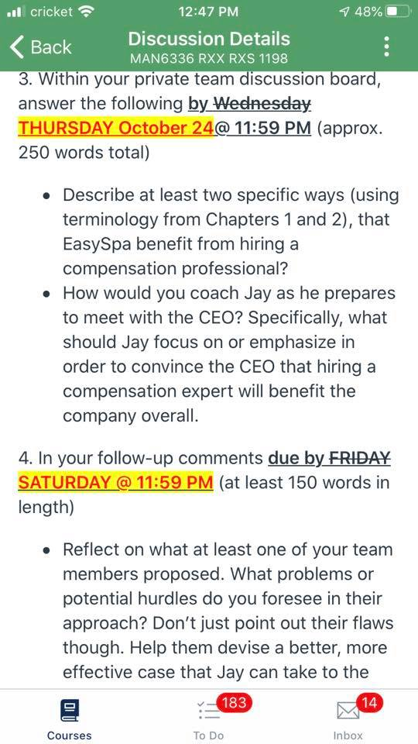

Suggestions for Synchronous Teaching: It may be necessary to change your approach to teaching to take advantage of the online environment. Here are some approaches to consider:

- Lecture-Based Teaching. It can be hard to get a sense of how a lecture is going online, and whether students are engaged. The usual verbal and non-verbal cues you can easily perceive in class are muted in a video conference. You can use Poll Everywhere and other audience response tools to keep students attention (and also grade on participation). The discussion and chat functions of your video conference platform can also be used to collect questions and encourage interactions during your talk. You may also want to assign groups of students to present during part of the synchronous class, splitting it between a mix of lecture and presentation. If you have low-levels of interactions in your lectures, you may want to use pre-recorded short lectures, and use your synchronous time to react to discussion board questions or comments.
- “Flipped” Classrooms. For classes based around project work, you can record
lectures and have students view them asynchronously. Video conferencing
platforms have a record video feature, as does your LMS. Make sure the video is
no more than 15 minutes long. Use your in-class time to have students present
using screen sharing. They can share their projects and present their work. You
can then offer direct guidance, or feedback as students present.
- Active Learning. You can also assign group work during the synchronous parts
of the class, posing a question based on the reading or asking teams to solve a
problem. You can also hold break out sessions in through your video conference
platform in which teams work in separate online rooms and then reconvene to
report out. You can then ask teams to present this work to the rest of the class.
You can assign multiple opportunities for active learning over the course of a
single class.

Suggestions for activity/discussion led classes (Stanford, resource guide for online teaching:

Rethink your classroom activities to make the class more interactive even if Zoom/Google meet students don’t have ideal connections and aren’t able to hear and see everything perfectly.
  - Have students write and comment together on a shared Google Doc.
  - Try using Poll Everywhere or Google Forms to collect student responses, and then share results with both in-person and online students.

Consider making discussion questions available in advance in Canvas, etc. so that students can access the questions if screen sharing does not work. If sharing slides in advance to Canvas, share as PDFs, as students will be able to access the material on their phones.

For online negotiation sessions - First assign roles and pair students. Then, allow pairs of students to figure out a way to conduct a video together. Different students choose different options and it went better than assigning all of them a platform to use only meetup or skype etc.

Resources for online teamwork including team building team agreement and group activities https://www.purdue.edu/innovativelearning/supporting-instruction/portal/files/21_Teamwork.pdf?fbclid=IwAR2ud2VHKPNxUR3h7aBnyD2R7q6vFiXRYIZScnmt6er5_Z3kKGGvp7Qkczw

Suggestions for student presentations (From Stanford, resource guide for online teaching)
If students are sharing their presentations asynchronously:
- Ask students to record themselves at their screen, using a web camera, the built-in microphone on their computer, and screen sharing software combined to capture both their faces/persons as well as the slides on the screen.
  - Zoom, Jing, and Screencast-o-matic can be used for audio/video recording in this capacity, as can Quicktime (on Mac only).
    - If students want to use presenter notes while recording in Zoom in particular, they can follow the instructions to use two monitors with screen sharing. If students do not have access to two monitors, they can also use the screen sharing function in Google Slides by selecting to share only the window with the final slidedeck and NOT to share the window that pops up with the presenter notes. (i.e. "squish" both windows so they could appear side-by-side).
  - Voiceover narration in slidedeck creation software can also be used via Keynote (Mac), PowerPoint (Mac or PC, PPT allows narration), or Quicktime (Mac).
  - Students can save their final recording file and upload it to your LMS (Canvas/Moodle). In this case you should make sure their presentations are available for other students. Submittal via assignment will enable instructors to see the presentations. Uploading to discussion to other students.

General tips:

- If you aren’t sure about your online class plans, run them by a colleague and see
if your class/plan makes sense to them.

- Try something new. If you don’t generally use discussion boards, try a new
exercise e.g., have students create memes of a concept learned in class, or take a
have students draw a concept map and post that picture – both exercises can
prompt a rich discussion during your online class1.

- If you have guest lecturers scheduled, send that lecturer a video conference link;
they can join the class remotely. If this isn’t possible, interview the lecturer and
record the interview and show it in class1.

- When you share a screen through your platform so you can show your
presentation or prepared debrief, use lots of visuals1.

- Encourage community: the sense of presence will be enhanced when everyone shows their face via their webcam. Consider requiring students to turn on video as a key part of participation, since it is easier to engage with the class if you can see them, and students are more likely to pay attention if they know they’re on camera. The gallery view can be helpful here.
- Stretch times: consider permitting students to “stretch” every 20-30 minutes for 30 seconds. It can be harder to focus attention on a screen than in a classroom!

Tech tools to offer synchronous remote delivery:

- Bluejeans- provides an interoperable cloud-based video conferencing service that connects participants across a wide range of devices and conferencing platforms.

- Zoom Video Conferencing. A free (but limited ) zoom account can be set up for 40 minutes conference calls for upto 100 participants. This can also be a useful tool for students to use independently for remote coordination of classroom projects. For a quick guide on how to set up a meeting and use it to narrate your slides see the link here. For basic training for ZOOM use here is a link to the tutorial offered at UCI

A Short video for academics that demonstrates how to use Zoom- Quick Zoom How-To Video for Academics

To create a virtual background using zoom: Open your Zoom client, and in the settings menu, look for the option "Virtual Backgrounds". Click "Add Image" then select the image you want, or choose to add a video.

- Google meet video conferencing App. It is fully integrated with G Suite, so you can join meetings directly from a Calendar event or email invite. For a comparison of features of Zoom and Google meet you see the link here. Google meet can also be used to set up virtual office hours. For a tutorial see here

- Nearpod- you can upload ppt slides on nearpod and add polling and discussion board activities on the nearpod platform. For nearpod youtube videos see- https://youtu.be/bhTCH3VMef0

- Online live Polling tools: Mentimeter, Polleverywhere

Few resources to calm your or your students’ minds amid this stressful time + our role as educators during traumatic times:

- Jane E. Dutton , Peter J. Frost , Monica C. Worline, Jacoba M. Lilius
and Jason M. Kanov (2002) Leading in Times of Trauma Harvard Business Review.

- Judith A. Clair, Tammy L. MacLean and Danna N. Greenberg 2002 Teaching through traumatic events: Uncovering the choices of management educators as they responded to September 11th. Academy of Management Learning and Education. 1(1): 38-54

- Danna Greenberg, Judith A. Clair & Tammy L. Maclean 2007 Enacting the role of management professor: Lessons from Athena, Prometheus, and Asclepius. 2007 Academy of Management Learning & Education. 6(4) 439-457.

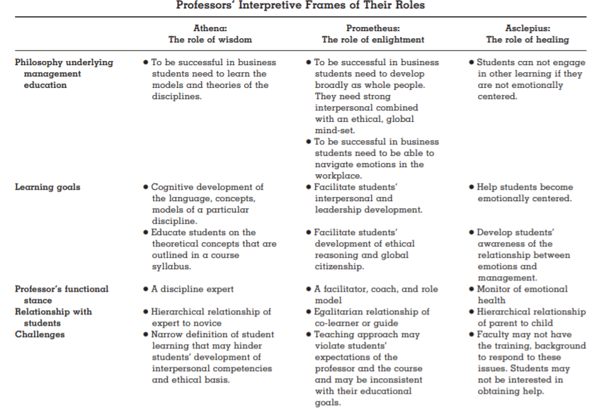
List of Websites/References for additional advice for the rapid move toward remote delivery:

Zooming into Remote Work: A Virtual Conversation, Harvard Business School (The first 5 minutes of this conversation is about background images that might be helpful if you have to run meetings or teach on zoom from home). It also includes a discussion on creating a routine, connecting with colleagues, virtual presentations, and flex work time to make the most out of working from home. https://www.youtube.com/watch?v=4qpmiY56JRk&feature=youtu.be

Humanizing online teaching: https://docs.google.com/document/d/1Umj2HpNZcscye2REOZPTONfKMjevC-qBsB5NneJ-HF0/edit

Short summary of suggestions for moving classes online
https://www.dropbox.com/s/22bew9zkw0nvvk1/Hints%20for%20moving%20classes%20online.pdf?dl=0]

Harvard tips on teaching remotely
https://teachremotely.harvard.edu/?fbclid=IwAR2ntu7eQU5_KM0v0tNXJgxNr2tfXBCOuv49lpRzX15qTqzOeJ-ghBboeKI

Going online in a Hurry
https://www.chronicle.com/article/Going-Online-in-a-Hurry-What/248207?utm_source=Iterable&utm_medium=email&utm_campaign=campaign_1073100&cid=at&source=ams&sourceId=2153148&fbclid=IwAR1CrCSHWRKdhLznjsp9c2zeANTkAl_p95AI0vwLWiWyVPNnC6OgR5sxcHM

Stanford resource guide for online teaching- https://docs.google.com/document/d/1ccsudB2vwZ_GJYoKlFzGbtnmftGcXwCIwxzf-jkkoCU/preview?fbclid=IwAR2x8JFlo1FrC3CbLZNsWrVsMMq0rjow8tZVyjmsVeS7il-JFCIiIkDAE3A

Going Online in a Hurry: What to Do and Where to Start:
https://www.chronicle.com/article/Going-Online-in-a-Hurry-What/248207?utm_source=Iterable&utm_medium=email&utm_campaign=campaign_1073100&cid=at&source=ams&sourceId=2153148&fbclid=IwAR027Ct9vKHqwFjFyUWCYJzOvkx8CCyIXzAHn5bDl30jG3IS1JAT5lB6QHQ

Tips and Tricks for Teaching in the Online Classroom: Jim Harrison and J. Diane Martonis (Faculty Focus)

Selecting the Appropriate Communication Tools for Your Online Course: Rob Kelly (Faculty Focus)

8 Lessons Learned from Teaching Online: EDUCAUSE Research Library

How To Be a Better Online Teacher: Flower Darby (Chronicle of Higher Education)

Birch, J.R. (October, 2019). Moderation Tips for Online Learning. Retrieved from:
https://trainingindustry.com/articles/e-learning/moderation-tips-for-onlinelearning/

Darby, F., & Lang, J. M. (2019). Small Teaching Online: Applying Learning Science in
Online Classes. John Wiley & Sons.

Darby, Flower. How to be a better online teacher. Advice Guide. The Chronicle of Higher
Education. Retrieved from: https://www.chronicle.com/interactives/advice-onlineteaching

Howard, J. R. (2015). Discussion in the college classroom: Getting your students engaged
and participating in person and online. John Wiley & Sons.

Kraut, R. E., & Resnick, P. (2012). Building successful online communities: Evidence-based
social design. Mit Press.

Matias, J. N. (2019). Preventing harassment and increasing group participation through
social norms in 2,190 online science discussions. Proceedings of the National
Academy of Sciences, 116(20), 9785-9789.

Mazzolini, M., & Maddison, S. (2007). When to jump in: The role of the instructor in
online discussion forums. Computers & Education, 49(2), 193-213.

Ouyang, F., & Scharber, C. (2017). The influences of an experienced instructor's
discussion design and facilitation on an online learning community development:
A social network analysis study. The Internet and Higher Education, 35, 34-47.

Pendry, L. F., & Salvatore, J. (2015). Individual and social benefits of online discussion
forums. Computers in Human Behavior, 50, 211-220.

https://www.chronicle.com/article/Going-Online-in-a-Hurry-What/248207?utm_source=Iterable&utm_medium=email&utm_campaign=campaign_1073100&cid=at&source=ams&sourceId=2153148&fbclid=IwAR027Ct9vKHqwFjFyUWCYJzOvkx8CCyIXzAHn5bDl30jG3IS1JAT5lB6QHQ
[Source Mollick, “Some Hints for Moving Classes Online” https://www.dropbox.com/s/22bew9zkw0nvvk1/Hints%20for%20moving%20classes%20online.pdf?dl=0]
[Source Mollick, “Some Hints for Moving Classes Online” https://www.dropbox.com/s/22bew9zkw0nvvk1/Hints%20for%20moving%20classes%20online.pdf?dl=0]
https://hbr.org/2020/03/how-to-get-people-to-actually-participate-in-virtual-meetings?fbclid=IwAR2XU6tbF6MXSBVBJ4uLD31rWU2sDzE81bmmoXVhUPTKDdfjjFI-cCM7Etk
Source Mollick, “Some Hints for Moving Classes Online” https://www.dropbox.com/s/22bew9zkw0nvvk1/Hints%20for%20moving%20classes%20online.pdf?dl=0]
[Source Mollick, “Some Hints for Moving Classes Online” https://www.dropbox.com/s/22bew9zkw0nvvk1/Hints%20for%20moving%20classes%20online.pdf?dl=0]
[Source Mollick, “Some Hints for Moving Classes Online” https://www.dropbox.com/s/22bew9zkw0nvvk1/Hints%20for%20moving%20classes%20online.pdf?dl=0]
https://teachremotely.harvard.edu/best-practices
https://teachremotely.harvard.edu/best-practices

